Predicting Depression in University Students Using Machine Learning Techniques
Jonathan Diaz. Autor, Master IA and Data Science, Universidad Autonoma de Occidente, jonathan_gir.diaz@uao.edu.co
Abstract--Depression affects millions of people worldwide and is one of the most prevalent mental health disorders, particularly among young adults. University students are a highly vulnerable group due to academic, work-related, and social stressors. Traditional diagnostic methods rely on clinical assessments that are often conducted at later stages of the illness, reducing the window for early intervention. This study proposes a predictive model based on machine learning techniques to help identify students at higher risk of depression, thus enabling timely intervention. Three classification algorithms—Logistic Regression, Decision Tree, and Random Forest—were evaluated to determine the optimal performance for this task. Results show that both Logistic Regression and Random Forest achieved an F1-Score of 0.85 and a ROC-AUC of 0.81, with a recall above 85%, demonstrating their practical applicability for early warning systems in academic settings.

Keywords — Depression, university students, machine learning, classification, public health prevention.

I ntroduction
D
epression is a widespread mental health disorder that affects emotional, cognitive, and physical well-being. According to the World Health Organization (WHO), over 300 million people globally suffer from depression, making it one of the leading causes of disability worldwide. University students are particularly susceptible to depression due to academic pressure, financial stress, social transitions, and the lack of effective support networks [1].
Traditional depression diagnostic methods rely on clinical interviews and self-reported questionnaires, which, while effective, are typically conducted only after symptoms become apparent. Machine learning (ML) offers a promising alternative, allowing the development of predictive models that can identify individuals at risk even before symptoms fully manifest [2].
This project proposes a machine learning-based approach to predict depression risk among university students. By analyzing a broad range of factors and utilizing publicly available data, the goal is to provide an automated tool that facilitates early intervention and enhances institutional mental health support.

Problem Statement
Depression in the university context is often underdiagnosed and stigmatized. Many students do not seek professional help due to fear of discrimination, lack of awareness about symptoms, or unawareness of available support services. Early detection of at-risk students would enable more effective deployment of prevention and intervention programs.
The objective of this work is to develop a binary classification model to predict whether a student is at risk of depression using demographic, academic, lifestyle, and personal background data. The aim is to complement traditional clinical methods with a data-driven tool, thereby improving institutional response capabilities in mental health.

Methodology and Data
A. Dataset
The dataset used in this study was obtained from the Kaggle platform and contains 27,900 records with 17 variables related to university students. The variables cover diverse information, including:
Demographic variables: Age, Gender, City.
Academic variables: CGPA, academic pressure, study satisfaction.
Lifestyle variables: sleep duration, dietary habits, work-related pressure, job satisfaction.
Additional factors: profession, university degree, financial stress, family history of mental illness, suicidal thoughts.
The target variable is Depression Status, binary: 0 = Not at risk, 1 = At risk.

B. Data Preprocessing
1) Categorical Variable Encoding
One-Hot Encoding and Label Encoding were applied to categorical variables such as dietary habits and family history. For example, the variable "Have you ever had suicidal thoughts?" was transformed into binary values (1 = Yes, 0 = No).
2) Ordinal Variable Conversion
Variables such as Dietary Habits were ordinally encoded, assigning numerical values that respect their semantic hierarchy.
3) Numeric Variable Normalization
Min-Max Scaling was applied to prevent variables with different ranges from dominating the model training process. Variables such as age, sleep duration, and study hours were normalized.
4) Handling Missing Values
Missing or inconsistent values were identified and handled through imputation with mode or mean, as appropriate, ensuring dataset completeness prior to training.
5) Data Splitting
The dataset was split into a training set (75%) and a test set (25%). The dataset is relatively balanced, with 58% of students classified as "at risk of depression," allowing adequate model training without the need for resampling techniques.
C. Model Selection
Three classification algorithms were selected based on their complementary characteristics:
1. Logistic Regression: simple linear model, interpretable, commonly used as a baseline.
2. Decision Tree: non-linear model, interpretable, capable of capturing complex relationships.
3. Random Forest: ensemble of decision trees, robust and with high predictive power.

Results
A. Evaluation Metrics
The following metrics were used to evaluate model performance:
Accuracy: overall percentage of correct predictions.
Recall (Sensitivity): model’s ability to detect positive cases.
F1-Score: balance between precision and recall.
ROC-AUC: model’s ability to discriminate between classes.
B. Model Comparison

TABLE I
MODEL COMPARISON
Model | Accuracy | Recall (Depression) | F1-Score | ROC-AUC
Decision Tree | 0.75 | 0.79 | 0.78 | 0.74
Logistic Regression | 0.82 | 0.88 | 0.85 | 0.81
Random Forest | 0.82 | 0.86 | 0.85 | 0.81

C. ROC Curve Analysis
Random Forest: curve well curved toward the upper left corner, indicating high discriminative power.
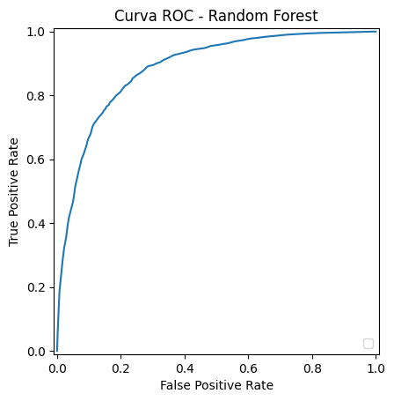
Fig. 1. ROC Random Forest

Decision Tree: curve close to the diagonal, indicating low discriminative power.
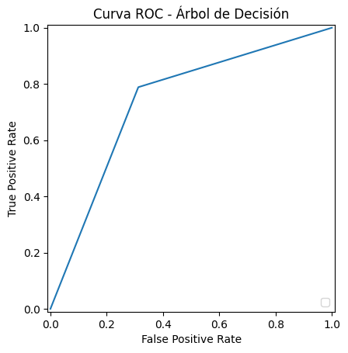
Fig. 2. ROC Decision Tree

Logistic Regression: curve well curved toward the upper left corner, indicating high discriminative power.
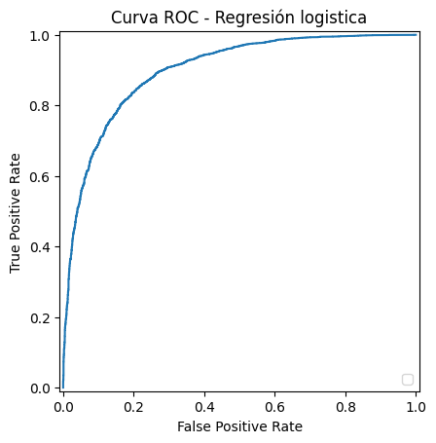
Fig. 3. ROC Logistic Regression

D. Interpretation
The Logistic Regression model achieved the highest recall (88%), which is crucial in mental health problems where it is preferable to tolerate a higher number of false positives rather than miss real cases. The Random Forest model demonstrated balanced performance, combining good recall with robustness against overfitting.

Practical Applications
This type of model has multiple applications in university environments:
Implementation in early warning systems to detect students at risk.
Additional tool for counselors and mental health services.
Optimization of institutional resources in wellness programs.
Reduction of stigma by offering indirect and automated assessments.
A practical implementation could be through a web-based application integrated with academic and wellness management systems.

Conclusions
Three classification models were implemented and compared, yielding solid results. Logistic Regression and Random Forest stood out for their ability to enable early detection (recall above 85%). The Decision Tree model showed limitations in generalization.
Despite the strong results, several limitations were identified, such as the geographic representativeness of the dataset and the self-reported nature of the data. Future work includes:
Conducting cross-cultural validations.
Developing longitudinal studies to model the evolution of risk factors.
Integrating models into real institutional platforms for operational evaluation.
This study demonstrates the potential of machine learning as a complementary tool for addressing public health challenges in the academic setting, specifically in supporting mental health interventions.

Acknowledgments
The author wishes to thank the university Autonoma de Occidente and the Master’s Program in Data Science and Artificial Intelligence for supporting this project. Special thanks to fellow students and professors whose feedback enriched this work.

References

- [1] H. Abdulla M., “Student Depression Prediction Using Machine Learning”, GitHub, 2023. [Online]. Available: https://github.com/HayaAbdullahM/Student-Depression-Prediction-Using-Machine-Learning. [Accessed: Jun. 9, 2025].
- [2] F. Torres Cruz, E. E. Coaquira Flores, S. J. Condori Quispe, “Prediction of Depression Level in University Students through a Naive Bayes based Machine Learning Model”, arXiv, Jul. 25, 2023. [Online]. Available: https://arxiv.org/abs/2307.14371. [Accessed: Jun. 9, 2025].
- [3] M. R. Chowdhury, W. Xuan, S. Sen, Y. Zhao, Y. Ding, “Predicting and Understanding College Student Mental Health with Interpretable Machine Learning”, arXiv, Mar. 11, 2025. [Online]. Available: https://arxiv.org/html/2503.08002v1. [Accessed: Jun. 9, 2025].
- [4] T. Biswas, D. Bhattacharya, D. Rudrapal, S. Roy, “Machine Learning for Forecasting Depression and Anxiety in University Students”, SpringerLink (ICTCS 2023), Apr. 28, 2024. [Online]. Available: https://link.springer.com/chapter/10.1007/978-981-97-0210-7_7. [Accessed: Jun. 9, 2025].
- [5] A. Lin Luo et al., “Predictors of Depression among Chinese College Students: a Machine Learning Approach”, BMC Public Health, Feb. 5, 2025. [Online]. Available: https://bmcpublichealth.biomedcentral.com/articles/10.1186/s12889-025-21632-8. [Accessed: Jun. 9, 2025].
- [6] “EduPsyCare: Predicting Student Depression”, GitHub, 2023. [Online]. Available: https://github.com/GiapDN-13/EduPsyCare. [Accessed: Jun. 9, 2025].
- [7] “In small study, machine-learning tech can identify suicidal tendencies”, Axios, Oct. 31, 2017. [Online]. Available: https://www.axios.com/2017/12/15/in-small-study-machine-learning-tech-can-identify-suicidal-tendencies-1513306565. [Accessed: Jun. 9, 2025].

 

